**Linux Environment Variable Assignment**

Q 1. Create a script “myscript” and perform following?

1. To create subdir in current directory à mkdir subd1 in myscript.sh

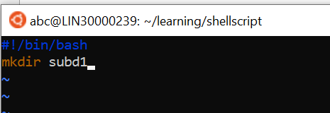

1. To create a file dircontent with contents of current directory à ls -l ./ > dircontent

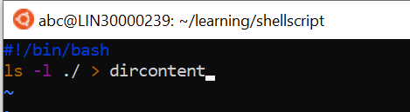

1. display the contents of the file “dircontent”

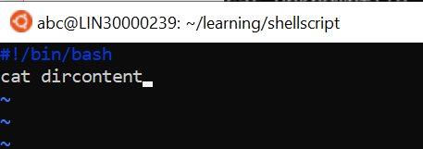

1. display the contents of a non-existing file named “unknownfile”

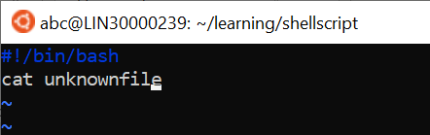

Q2. Run the script and validate the output in following cases

1. Redirect only the stdout to an o/p file named stdout.txt

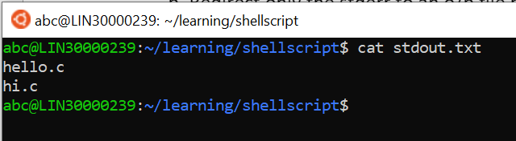

1. Redirect only the stderr to an o/p file named stderr.txt

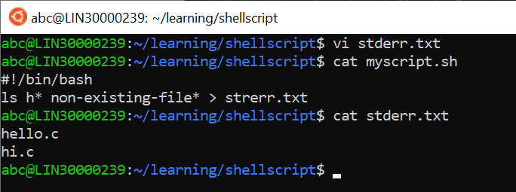

1. Redirect both stdout and stderr to an o/p file named stdall.txt

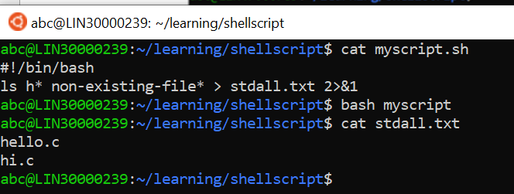

1. Display all o/p and error  and also redirect both stdout and stderr to an o/p file      named stdall.txt

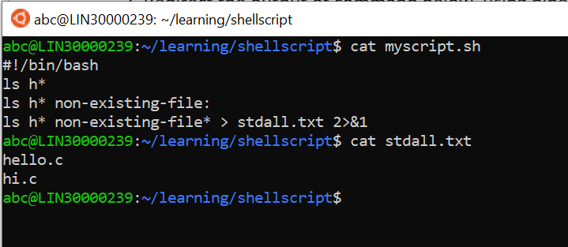

Q3) Redirect the output of command below  using pipe (|) to wc  and get the output.

ls -l

